**TRUMP AND HORNS ACADEMY**

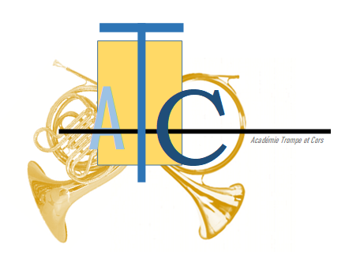

**Trumpe and Horns, in agreement!**

The imagination of the general public spontaneously associates hunting with trumpets and horns, without necessarily making the difference between the two instruments. It is true that at a certain time the one and the other did not differ.

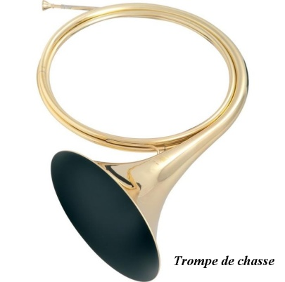Currently, in a presentation, each occupies a specific area. Why this decoupling? But also why this association?

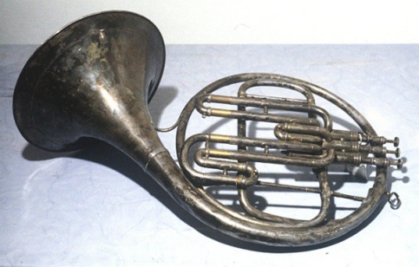

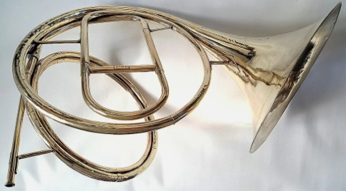

Single tone horn 1st French horn

**In hunting as in war!**

In the earliest times, the horn was an integral part of everyday life. Thus, the presence of the horn in the Bible is characterized by the shofar, a horn made from a ram's horn.

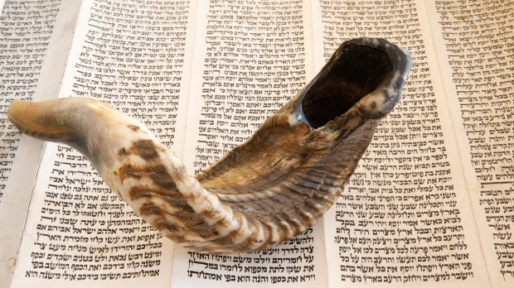

Pascal Deloche / Godong

This instrument takes on a double aspect, religious and military: “In front of the ark, seven priests will carry seven ram’s horn trumpets. On the seventh day, you will circle the city seven times, and the priests will blow the trumpet. When the ram's horn sounds – when you hear the sound of the horn – all the people will shout with a great shout; then, the rampart of the city will collapse in place and the people will attack, each one straight ahead. (Js 6, 4-5).

The essential quality of this instrument is to allow easy and powerful remote communication, especially in war or hunting.

Its presence is attested among the Etruscans, the Greeks, the Romans and later in the Middle Ages.

The horn was then a simple instrument, of limited size given the conditions of use.

However, its technical capacities limit its use: short or long sounds, low tone called "big tone" or hail. However, this makes it possible to articulate a system of signals adapted to the context of hunting. Hardouin de Fontaine-Guérin's book, written around 1394, the "Trésor de Vénerie" lists 14 calls specifying the way to "corner" them, these calls being called "cornures" that is to say ringtones.

In his book on Saint Louis, the historian Jacques Levron reports the following event during the Egyptian Crusade: "Then broke the first assault in a dreadful din in which mingled horns, whelks, drums and people's cries ".

**Arts, technology and science, a winning trio!**

The horn thus confined to the emission of more or less codified signals will evolve from the Renaissance when a new vision of the arts will allow significant technical progress.

While in the Middle Ages, hunting was an essential ritual function, incumbent on the king and the aristocracy, during the Renaissance hunting became a major sign of royal power used by the French Monarchy. Passionate hunters, François 1er and later Louis XV were its most fervent followers.

Under the effect on the one hand of technical progress making it possible to bend metal tubes and on the other hand of the progress of scientific knowledge, particularly with regard to the laws relating to partials, metal instruments are gradually spreading. Father Marin Mersenne, a Parisian Minime monk, in Harmonie Universelle (1636) studied the horn in detail indicating that a good hunter can produce several notes on a wound horn. From now on new paths are possible: the evolution of the simple hunting horn towards an instrument capable of giving several sounds is launched: the horn can become an orchestral instrument.

The vocabulary then integrates this evolution. From now on we will speak of horn for hunting and horn for music probably because of the pastoral character associated with it even if the term "horn" remains in common use.

**Horn and trumpet, each his own technique**

In the 17th and 18th centuries, royal hunting marked by the desire of the monarchs to make it a remarkable activity, promoted the arrival of a more musical instrument favoring the magnificence of the court, recording the birth of the modern trumpet.

We cannot ignore the Marquis de Dampierre, considered the founding father of the repertoire of hunting bands. Appointed in 1722 gentleman of the Menus Plaisirs du Roi, known as a brilliant performer, it was in 1723 that he created a major event bordering on scandal because he was an aristocrat; he had the audacity to ring in front of the king, during a hunt in the Bois de Boulogne, a brass band which will be called "la Royale". You should know that the horn is then sounded by servants posted at selected locations without using a truly specific repertoire of hunting music. The collection of brass bands attributed to him appeared well after his death and became the basis of hunting music. Over time, this music will be enriched and will take on its full autonomy.

He adopts an impractical instrument, called a "Dampierre horn", wound on a turn and a half, which attracts attention.

In 1729, a new model appeared to facilitate the use of the horn for hunting: a horn wound on two and a half turns, called "Dauphine", on the occasion of the birth of the Dauphin Louis, eldest son of Louis XV.

In addition, if the practice evolves with the use of blocked sounds, notable technical developments are emerging in particular thanks to the technical research of German and Austrian makers who made the trumpet or the hunting horn evolve until it became a horn. harmony is – to – say an orchestral horn. The piston was invented in 1815 by Stötzel

Two paths therefore emerge: the trumpet, technically developed for hunting and the horn, a chromatic instrument intended for the orchestra.

**… Everyone has their own repertoire**

Composers who wished to represent the hunt therefore incorporated the horn into their works: J.B. Morin (1677 – 1745), La Chasse du Cerf given for the first time in Fontainebleau for Saint Louis, on August 25, 1708 before King Louis XV where the he author has taken up airs of venery, such as the “Sourcillade” which has become the View; JS Bach (1685 – 1750), Cantata of the Hunt; J. Ph. Rameau (1706 – 1764) in Les Boréales; J.J. Haydn (1732-1809), Symphony No. 73, The Hunt. One could cite many other composers. It is the whole Baroque period where the natural horn is used in orchestral works.

During this time, the hunting horn spread in Europe thanks to Count von Sporck (1662 – 1738) who, seduced by the hunting horn, attracted by its timbre, its musicality and its elegance, sent two hunters to learn the horn at Versailles. On their return to Bohemia, they were the promoters of the art of ringing in their country and beyond. Count von Sporck is also the creator of the Order of Saint Hubert

From the end of the 18th century, the theme of the hunt inspired other composers who inserted hunting horn tunes into their works.

Thus, Carl Maria von Weber (1726 – 1826) composed the Freischutz whose chorus of hunters is famous for the use of the natural horn; Niccolo Paganini (1782 – 1840), for the violin, composed caprice n° 9, La Chasse; Ottorino Respighi, in “les fêtes de Rome”, 1928, where he takes up the Bonsoir, the Honors and the Hallalis.

**Way of the future: trumpet and horns, in harmony**

The contemporary period benefits from individual pipers of great talent, composers who are constantly enriching the repertoire of the trumpet.

Similarly, large hunting trumpet ensembles lead to progress through intense research into the way of expressing the trumpet in a group: musicality, expression, renewed forms of writing, advanced tonal harmony, association with other instruments, in particular the 'organ.

The modern horn or piston horn, when it has an immense repertoire, extremely present in the symphony orchestra. It is expressed in capital works such as the concerto for horn, op.8 (1865) by Franz Strauss, an exceptional horn player, by his son Richard who composed two concertos for horn (concerto n°1 in E flat major, concerto n° 2 in E flat major) and more recently Hindemith's horn concerto (1949) without omitting Richard Wagner where the horn is used in works that have become famous: "The Call of Siegfried" for example. They may be older dating from the Baroque era: Mozart, 4 horn concertos including one written in D major for the natural horn.

Each universe has its own colors. Bringing them together can only promote joint developments bringing new wealth.

Should everyone stay in their own lane?

The Trompe et Cors Academy (ATC) works with the idea of ​​bringing these two worlds closer together. It aims to bring together around a musical project, the whole family of horns, from the hunting horn to the modern horn, while keeping their specific practices.

The ATC has implemented actions in line with this philosophy. Supported from its creation by the President of the François Sommer Foundation, Mr. Philippe Dulac, appreciating the innovative idea.

On September 25 and 26, 2021, the ATC participated in the general assembly of the CIC (International Council for Game and Wildlife Conservation) in Budapest. She created on this occasion, with the active collaboration of the CIC, the European Trompe and Horn Ensemble.

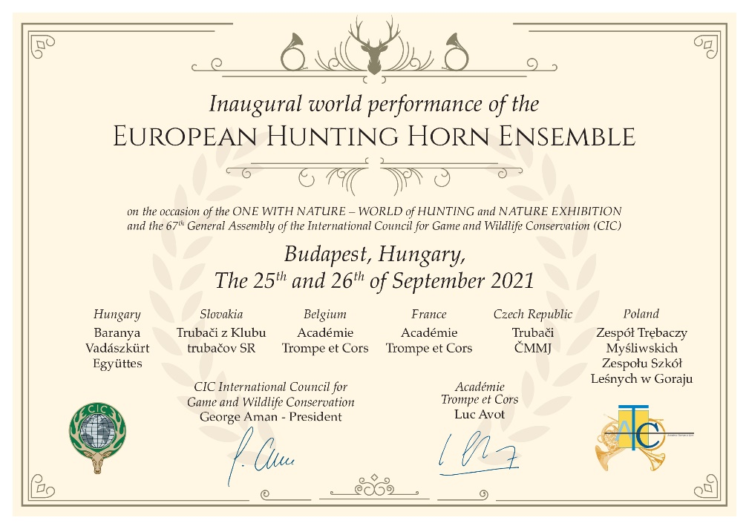

During the general assembly, a new piece, written especially for the occasion, founding of this ensemble, was performed by the six countries present: "EGYÜTT", that is to say "Ensemble", March for horns in Eb, Bb, trumpets in D, composed by Hervé Teknia.

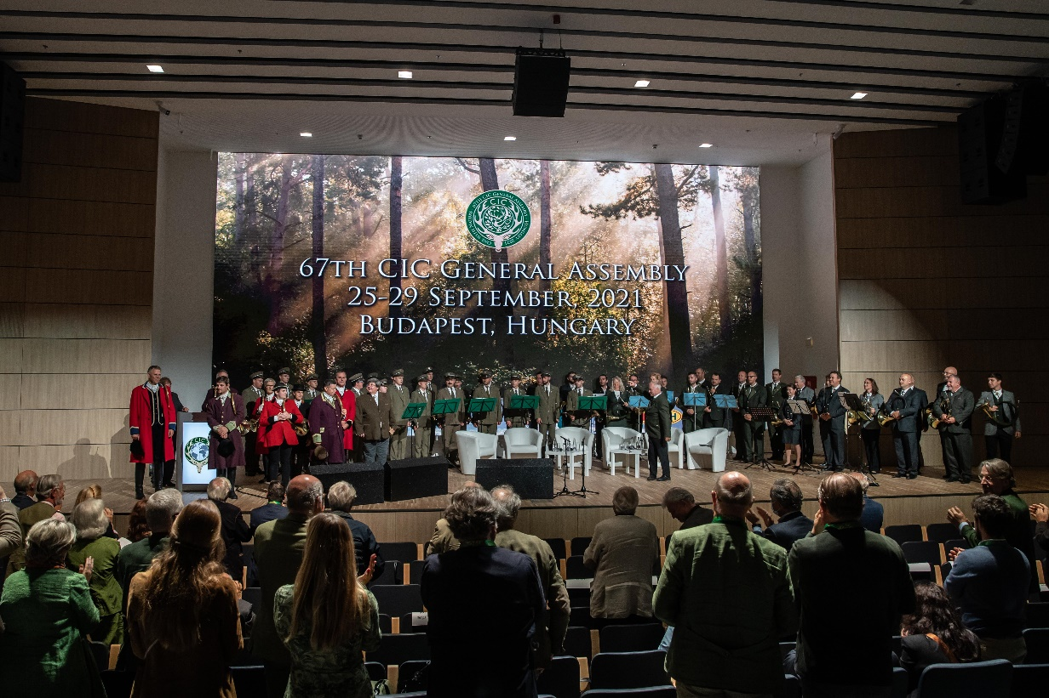

The French Horn Association (AFC) organized, on March 26 at the Conservatoire du Center in Paris, the COR DAY.

The ATC, a partner in this project, presented the hunting horn to an audience of teachers and students from conservatories.

The day ended with a joint concert at the Grande Canopée in Paris in front of a large and interested audience, alternating pieces specific to each of the i nstruments and pieces performed “Ensemble”, ending with an emblematic composition, “Rendez-Vous de Chasse” by Rossini, extremely acclaimed.

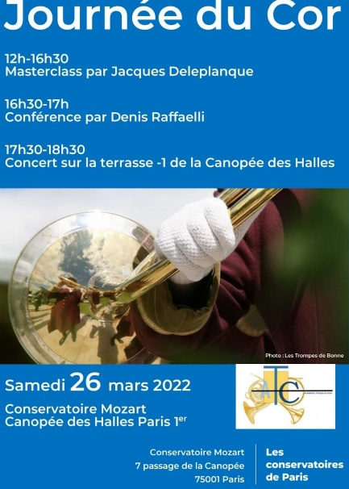

On June 4, 2022, the Geneva Conservatory of Music, where Franz Liszt was a teacher, will host a Study Day around the Hunting Horn and the Horn. This day will be hosted by Pierre Burnet, professor of the horn class, Victor Alvarado from Music-Ensemble and Denis Raffaelli representing the Trompe and Horns Academy.

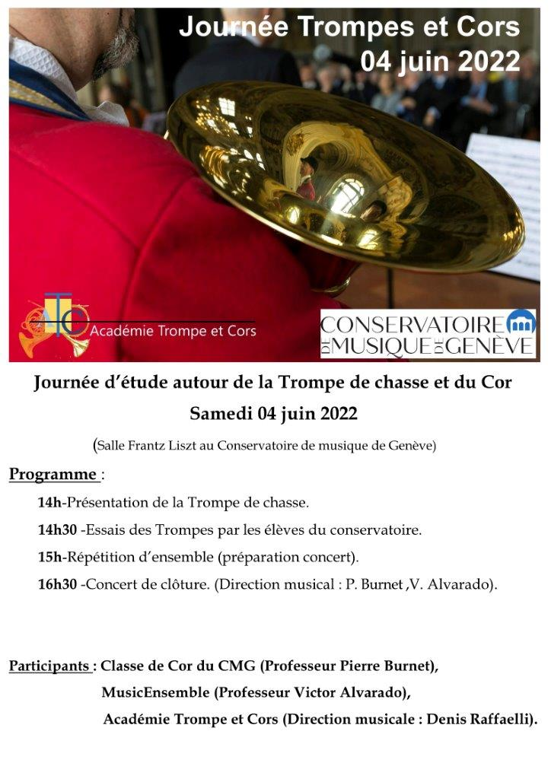

On December 5 will take place in Paris, within the framework of the CNSMD, a day dedicated to Charles Koechlin, composer, polytechnician, passionate music teacher who composed in the years 1932 – 1935 many bell ringtones. Some of them will be produced for the premiere as well as other pieces by this very prolific composer.

Trumpe and horns, a common history that lives in common projects!

*Denis Raffaelli & Luc Avot,*

*Trumpe and Horns Academy*

 <https://www.facebook.com/atc.atc.9655>

*Bibliography:*

*Kurt Janetsky, Bernhard Brüchle, LE COR, Payot, Lausanne, 1977*

*Jacques Levron, Saint Louis or the Apogee of the Middle Ages, Librairie Académique Perrin, Paris, 1969*

*Jean Louis Couturier, Historical overview of the practice of the natural horn in France and its use in wind ensembles, Conference given in Bern (CH) as part of the International Romantic Brass Symposium (2012)*

*Jacques Poncet, Historical overview and perspectives, Colloquium “Art of the trumpet ringers”, Tours, 2013*

*Michel Rouffet & Eric Breton, How the hunting horn became a musical instrument.*